Operating systems-unit 3

**1. What is Segmentation? Explain with Example.**

Ans- A process is divided into Segments. The chunks that a program is divided into which are not necessarily all of the same sizes are called segments. Segmentation gives user’s view of the process which paging does not give. Here the user’s view is mapped to physical memory.

There are types of segmentation:

1. Virtual memory segmentation –Each process is divided into a number of segments, not all of which are resident at any one point in time.
2. Simple segmentation –Each process is divided into a number of segments, all of which are loaded into memory at run time, though not necessarily contiguously.

**2. What is virtual memory? Discuss the benefits of virtual memory techniques.**

Ans- Virtual Memory is a storage allocation scheme in which secondary memory can be addressed as though it were part of the main memory. The addresses a program may use to reference memory are distinguished from the addresses the memory system uses to identify physical storage sites, and program-generated addresses are translated automatically to the corresponding machine addresses.

The size of virtual storage is limited by the addressing scheme of the computer system and the amount of secondary memory is available not by the actual number of the main storage locations.

Benefits of virtual memory:

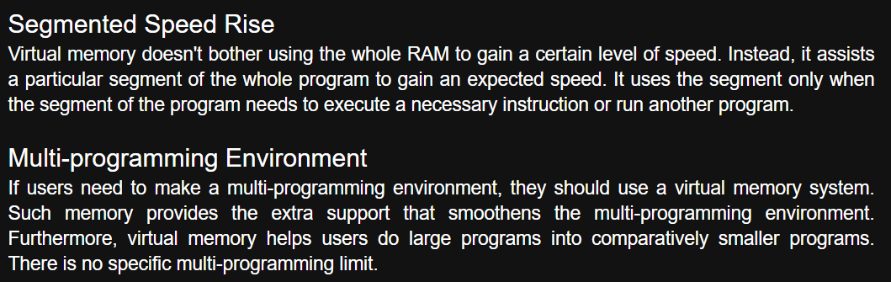

**3. Explain the concept of file with Example.**

Ans- A file is a named collection of related information that is recorded on secondary storage such as magnetic disks, magnetic tapes and optical disks. In general, a file is a sequence of bits, bytes, lines or records whose meaning is defined by the files creator and user.

**4. What are Pages and Frames? Explain External and Internal fragmentation?**

Ans- A page (or memory page, or virtual page, or logical page) is a fixed-length contiguous block of virtual memory. A frame (or memory frame, or physical page, or page frame) is a fixed-length block of RAM (ie. physical memory, it exists - as in "physical".

1. Internal Fragmentation:

Internal fragmentation happens when the memory is split into mounted-sized blocks. Whenever a method is requested for the memory, the mounted-sized block is allotted to the method. In the case where the memory allotted to the method is somewhat larger than the memory requested, then the difference between allotted and requested memory is called internal fragmentation.

2. External Fragmentation:

External fragmentation happens when there’s a sufficient quantity of area within the memory to satisfy the memory request of a method. However, the process’s memory request cannot be fulfilled because the memory offered is in a non-contiguous manner. Whether you apply a first-fit or best-fit memory allocation strategy it’ll cause external fragmentation.

**5. List two differences between logical and physical addresses.**

